Architecture modeling:

4+1 view:

1. Logical view
2. Process View
3. Development View
4. Physical view

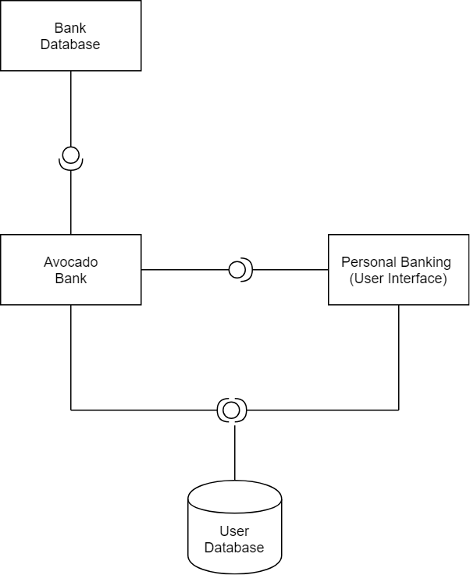

Fig.1: Logical View

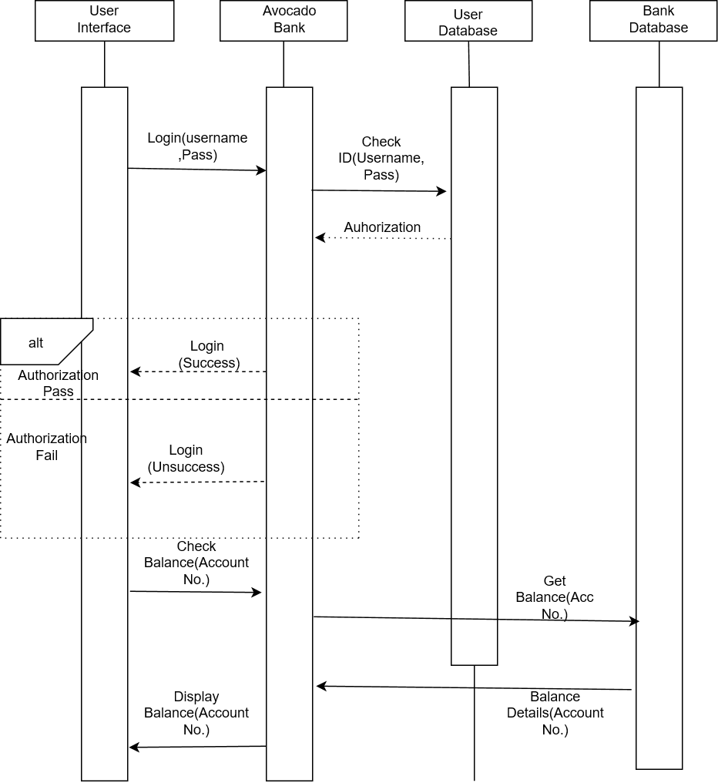

Fig.2: Process View

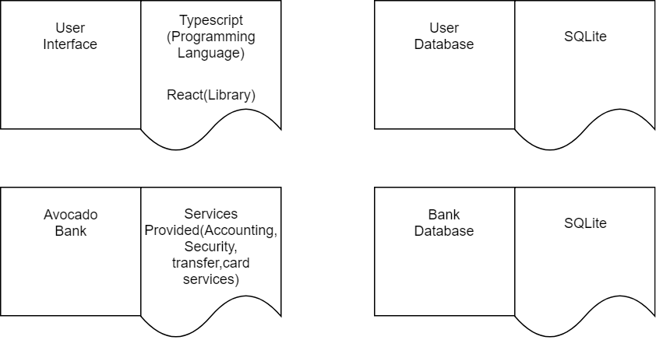

Fig.3: Development View

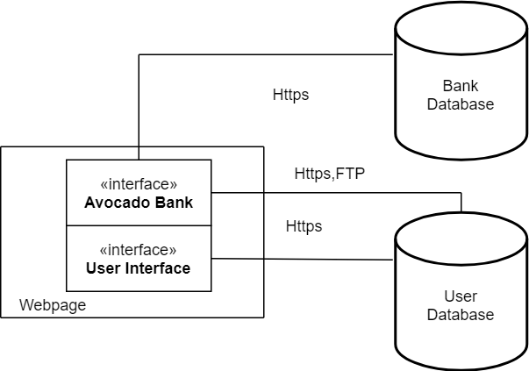

Fig.4: Physical View

Behavioral modeling (Dynamic Modeling):



Fig.5: Check Balance Use case

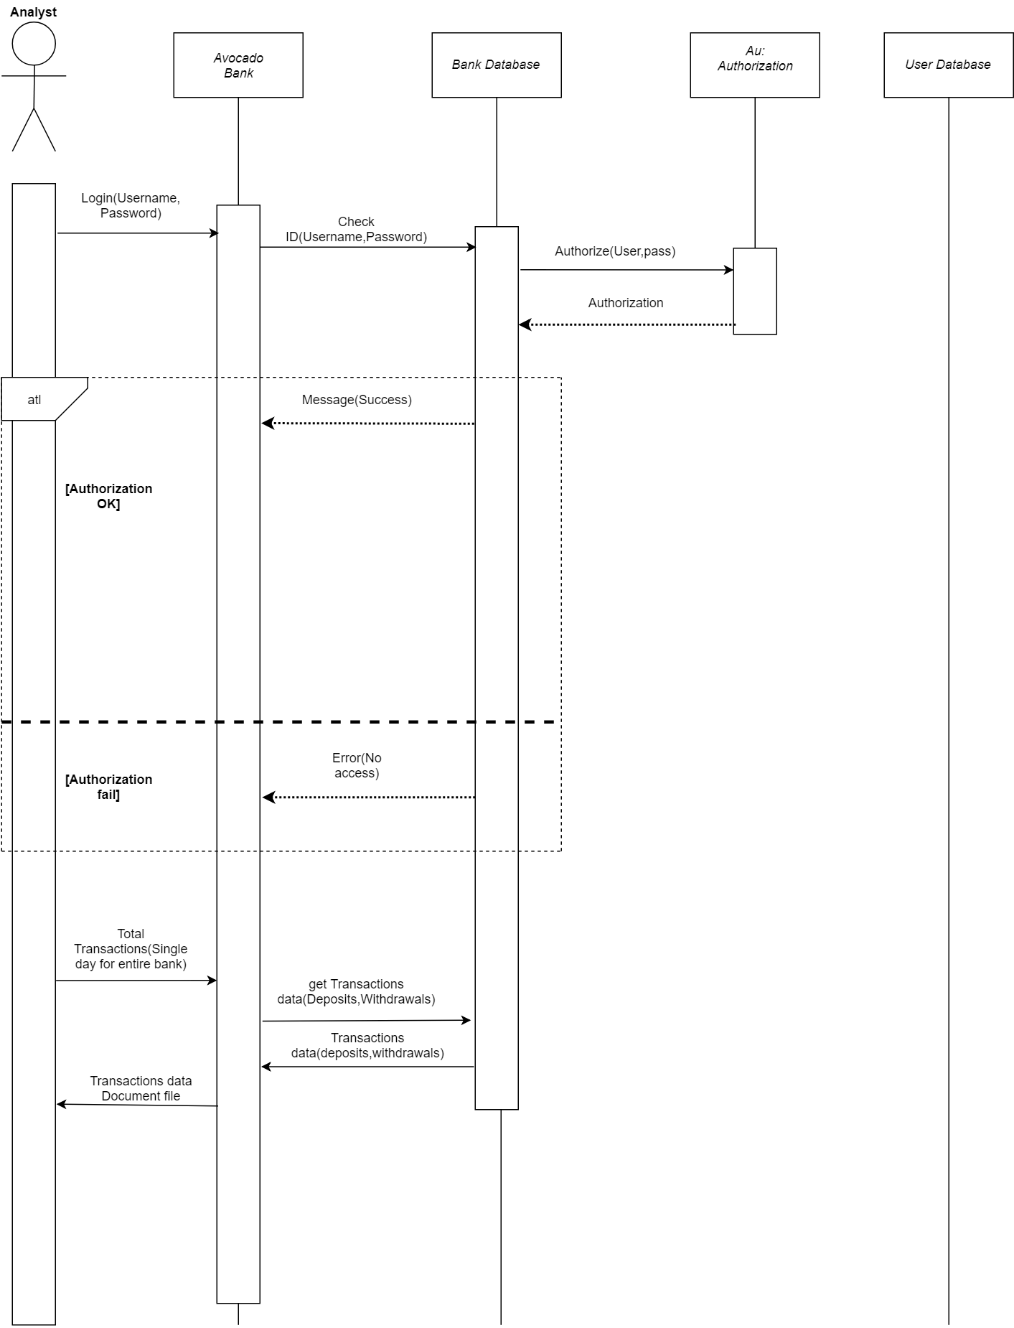

Fig.6: Get Transactional Data For Analyst Use case